**Heart Attack Prediction Model**

Heart disease, a prevalent global health concern, can benefit from data-driven insights. Leveraging machine learning, we aim to predict heart disease occurrence by analyzing medical histories, physiological measurements, and lifestyle factors. Through model training and evaluation, our study seeks to accurately differentiate patients with and without heart disease. Challenges include data quality and model complexity, demanding iterative refinement. This research aligns with the growing need for early detection, intervention, and personalized treatment strategies, ultimately improving cardiovascular healthcare outcomes.

 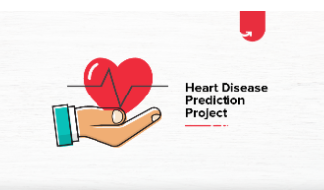

[Features Information:](https://archive.ics.uci.edu/ml/datasets/iris)

|  |  |  |
| --- | --- | --- |
| **Index** | **Feature** | **Description** |
| **1** | **age** |  |
| **2** | **sex** |  |
| **3** | **cp** | **Chest Pain** |
| **4** | **trtbps** |  |
| **5** | **chol** | **Cholesterol** |
| **6** | **fbs** | **fasting blood sugar** |
| **7** | **restecg** | **Resting electrocardiographic measurement** |
| **8** | **thalachh** | **The person’s maximum heart rate achieved** |
| **9** | **exng** | **exercise induced angina** |
| **10** | **oldpeak** | **The person’s maximum heart rate achieved. Exang: Exercise induced angina** |
| **11** | **slp** | **Speech and Language Disorders** |
| **12** | **caa** | **A coronary artery anomaly** |
| **13** | **thall** | **thalassemia** |
| **14** | **output** | **Target** |

|  |
| --- |
|  |
|  |

# ****Dataset link****

# <https://www.kaggle.com/datasets/johnsmith88/heart-disease-dataset/>

# Heat Map and importance of features

# 

# 

# 

# 

From the above graph, we observe that CP (Chest Pain)/ thalachh/Exng(exercise induced angina) and old peak are the highest features that correlate with the output.

# ****Data Visualization****

# ****Plot chances of heart attack****

# 

Total distribution of output is 1025 (526 has heart disease and 499 are not)

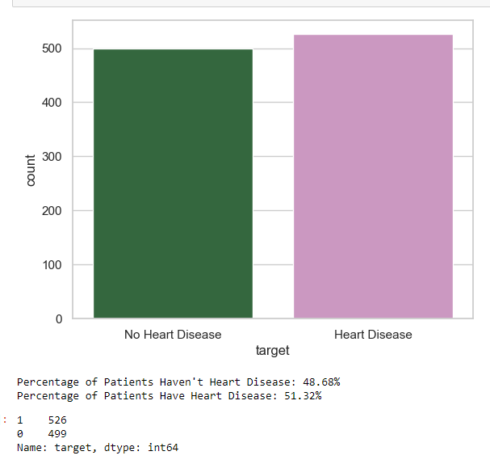

# ****Gender distribution for the study****

# 

# 

The study distribution shows that male is almost 2/3 as compared to 1/3 of female

# ****Correlation between sex and Heart Disease****

# 

# 

# Out of 312 Female, 226 were diagnosed with no disease while 86 have disease.

# Out of 713 Male, 413 were diagnosed with no disease while 300 have disease

# The percentage for heart disease for female is 27.5% (86/312) while it jumps to 42% for male (300/713)

**Heart Disease VS Age**

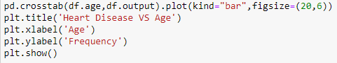

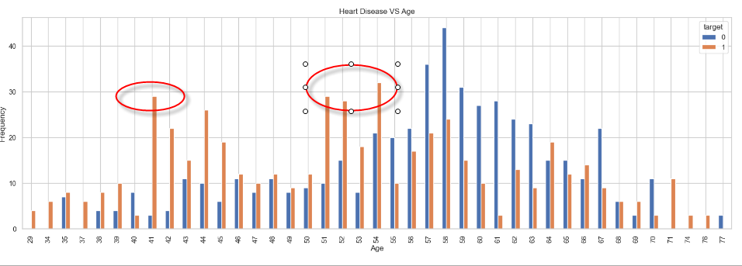

From the graph above, we can see that most of the heart disease samples are at age 41 as well as 51,52 and 54.

# ****SLP and output****

# 

# 

# There are high number of positive samples if SLP (Speech and Language disorders at stage 2)

# ****Correlation between FBS and output****

# 

# 

# The above graph shows that percentage of heart disease increase when it is > 120mg/dl while the percentage almost same when it is <120mg/dl

# ****Correlation between Chest pain type and output****

# 

# 

# Graph shows chest pain type 2 has high potential for heart disease while it is minimal for type 3

**Summary:**

**A variety of models were leveraged in the training process, supplemented with rigorous hyper parameter tuning methodologies. The performance of these models was rigorously evaluated based on key metrics AUC (Area Under Curve) , it emerged that the Decision tree model after second round of parameter tuning outperformed as compared to other model as AUC reached 97%**